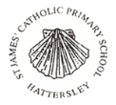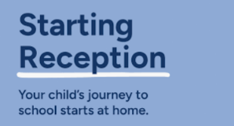

7.7.2025

Dear Parents/ Carers,

We are so pleased to welcome you and your child to our Reception Class, here at St. James’. This is the beginning of your child’s learning journey and truly where the magic happens!

We encourage you to read the booklet, ‘Starting Reception’, which you received with this letter.

As you will see from the front cover, your child’s journey to school starts at home. We are more than happy to support you on your child’s journey, but it is so important that you, as a parent/ carer engage with it also, to give your child the best possible start.

The booklet is a brilliant ’go to’ guide to help you and your child prepare and practise for the skills they need, to ensure an easier, positive transition and help them to grow in independence and confidence.

New skills take time to learn. If you start now, ready for September, it will make a big difference, not only, for your child, but for you also!

If you have any questions, please don’t hesitate to contact myself or Mrs Childs.

We are always here to help and support you and your child.

Thank you,

Mrs Dobie, Mrs Childs.