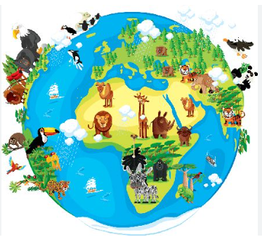 **Reception Knowledge Organiser Autumn 1 – God’s World**

**What will I see and hear to help me understand?**



God made our beautiful world and everything in it.

God made me.

The words and actions of the sign of the cross: ‘In the name of the Father, and of the Son and of the Holy Spirit. Amen’.

God created the world and said, ‘Indeed it is very good’ (Genesis 1:31).

The whole of Creation shows God love for us (Laudato Si’ 84–88).

Noah and the Flood

* Know that God made the world.
* Know that God asked us to care for the world.
* Know that God loves and cares for each one of us.
* Know that God made us all special in our own way.

**How will I discover more?**

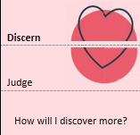

* I can think about all the things that God has made for us.
* I can think of how we can care for our world.
* I can reflect on what God’s love and care means to each one of us.
* I can reflect on how we can thank God for everything.

**Vocabulary**

* God
* creation
* awe
* wonder
* love
* peace
* light
* world
* Laudato ‘Si
* respect
* grateful
* Noah
* flood
* recognise,
* talk about,
* label,
* name,
* match,
* sort,
* retell,
* sequence,
* recall

**What can I do now?**

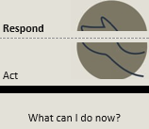

Look after me.

Look after God’s world.

Care and love for self, family, others, and God’s world. God made each of us, so each one of us is very special. We must treat others in a caring way because God made them too.

Dignity of the Human Person