|  |
| --- |
| **Home Learning Tips** |
| Watch our weekly  phonics videos on the  school website:  Class pages- Reception  (Coming soon!) |
| Listening for rhyme  and alliteration during  story time |
| Number Blocks on  CBeebies 1-5 |

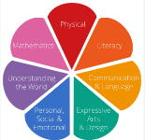**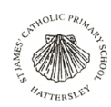 Reception Curriculum Map Autumn 1 2025**

|  |
| --- |
| **Areas of Learning** |
| **Personal Social and Emotional Developmen**t: Explain all about me and what makes me special. Learn about my feelings. Talk about people who are special to me and people who help me. |
| **Physical development:** Move in a variety of different ways and directions, negotiating space and changing speed. Recognising what exercise is doing to our bodies and notice changes. |
| **Expressive arts and design**: Explore a range of media and learn to use tools safely and effectively. Listen and respond to music. Sing a range of nursery rhymes. |
| **Understanding the world**: Express our thoughts and feelings related to special people including families, friends. Consider past events in their own lives and lives of family members and their family history |

**Marvellous Me**

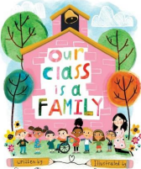

|  |  |
| --- | --- |
| **Maths** | **Key Vocabulary** |
| Recognise quantities to 3 without counting (subitising). Match and sort objects based on size, colour, shape… Compare amounts, size, mass, capacity… Make simple patterns | same  different  sort  match  count  total  altogether  subitise  more  less  position  pattern |

|  |  |  |
| --- | --- | --- |
| **Communication, Language and Literacy** | **Key Vocabulary** | **Vocabulary Definition** |
| Talk about the settings, key events and the characters in our focus texts. Identify rhyming and alliterative words in our focus texts. Begin our phonics programme and apply what has been learnt when reading and writing words, labels or simple captions. Explain their ‘mark making’ and to continue practicing their letter formation. Hear, say and write the initial sound in words. Begin to segment the sounds in simple words and blend them together | rhyme  alliteration  phonics  caption  mark making  initial sound | Words that rhyme sound the same at the end e.g., hen, pen  Words that begin with the same sound e.g., silly, small, sausages  Learning to read by linking sounds to letters  A brief explanation e.g. The three tractors.  The creation of different  patterns, lines and shapes.  The sound at the start of a  word e.g., s – seed / h - harvest |

|  |
| --- |
| **Key Curriculum vocabulary** |
| creation  Bible  ready emotions  respectful friendship  safe family  courage history  compassion past  respect unique  core values community  worship autumn  season |

