The Kapow Language comprehension and Language production skills strands align with the National curriculum aims for Languages. Our National Curriculum coverage document shows which units support you in helping children to reach each of the National curriculum attainment targets.

**How does Kapow Primary’s French scheme of work align with the National curriculum?**

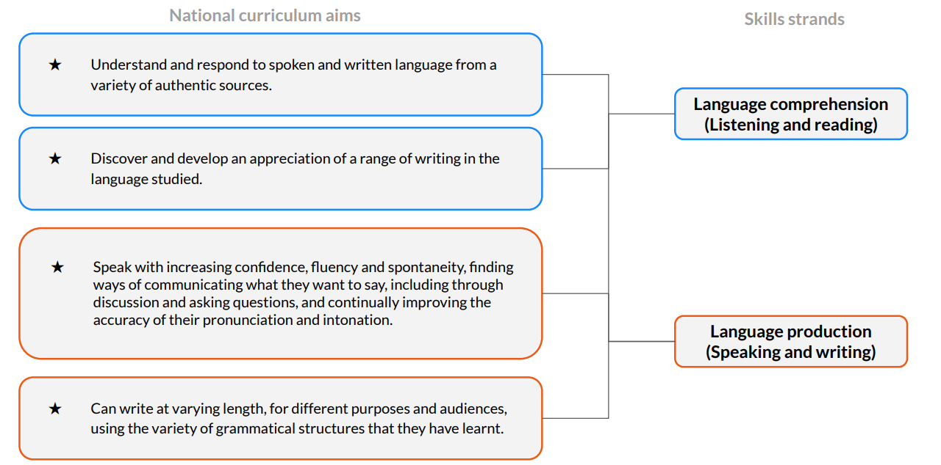

**How is the French scheme of work organised?**

**Language production**

**(**

**Speaking and writing**

**)**

**Cultural awareness**

**Language comprehension**

**)**

**Listening and reading**

**(**

**National curriculum guidance**

**Grammar**

**Vocabulary**

**Phonics**

Knowledge

strands

Skills

strands

Throughout the scheme of work, children will also be developing their Cultural awareness of France and the French-speaking world.

**Our knowledge strands - Phonics, Vocabulary and Grammar**

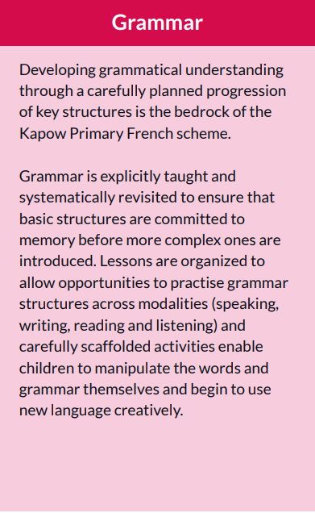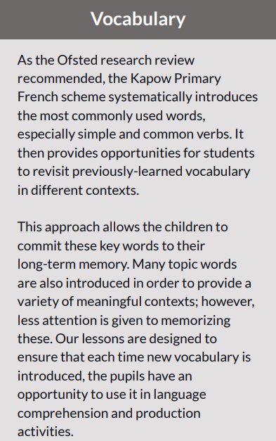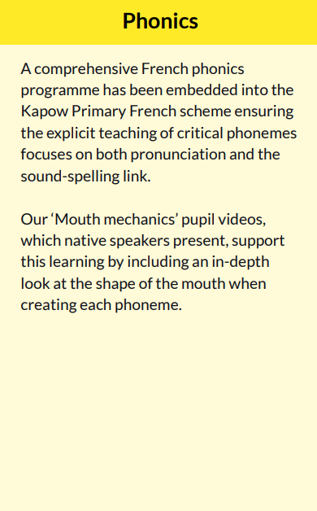

**A spiral curriculum**



✓ **Cyclical**: Pupils revisit key vocabulary and grammar concepts again and again.

✓ **Increasing depth**: Each time vocabulary or grammar learning is revisited, it is covered with greater depth

✓ **Prior knowledge**: Upon returning to each area, prior knowledge is utilised so pupils can build on previous foundations, rather than starting again.

**Assessment in French**

**Formative assessment**

Every lesson begins with the ‘Recap and recall’ section which is intended to allow pupils retrieval practice of key knowledge relevant to the upcoming lesson. This section also provides teachers with an opportunity to make informal judgements about whether pupils have retained prior learning and are ready to move on. Each lesson contains the ‘Assessing progress and understanding’ section which helps teachers to identify those pupils who are secure in their learning or working at a greater depth in each lesson. These assessments can then be recorded on our French: Assessment spreadsheet which supports the teacher in identifying gaps in learning amongst the class or for individual pupils.

**Summative assessment**

Each unit of work assesses children’s understanding and retention of key knowledge using an assessment quiz with multiple choice and open-ended questions. In addition, each unit uses a knowledge catcher. This can be used at the beginning and/or end of a unit and gives children the opportunity to further demonstrate their understanding of the key concepts covered. Assessment quizzes, and knowledge catchers provide teachers with a record of summative assessment as evidence of progression throughout the year and as pupils move between key stages. It is suggested that teachers keep all forms of assessment as children move through primary school so that the subject lead and teachers will have a record of children’s learning.

