**D.T Progression Narrative**

**Intent** to help assure curriculum breadth, coverage, content and a structure that enables clear progression in knowledge and skills: from lesson-to-lesson, term-to-term and year-to-year. (Ofsted Handbook, 157: “It is clear what end points the curriculum is building towards, and what pupils will need to be able to know and do at those end points … The school’s curriculum is planned and sequenced so that new knowledge and skills build on what has been taught before, and towards those defined end points.”)

**Implementation:** The teaching activities in the Kapow Schemes will help assure lively, effective and appropriate learning based on the structured Pathways.

**Impact:** assessment activities and frameworks help to demonstrate that teaching has resulted in clear and appropriate outcomes

The Kapow scheme of work fulfils the statutory requirements outlined in the national curriculum (2014). The national curriculum Programme of study for Design and technology aims to ensure that all pupils:

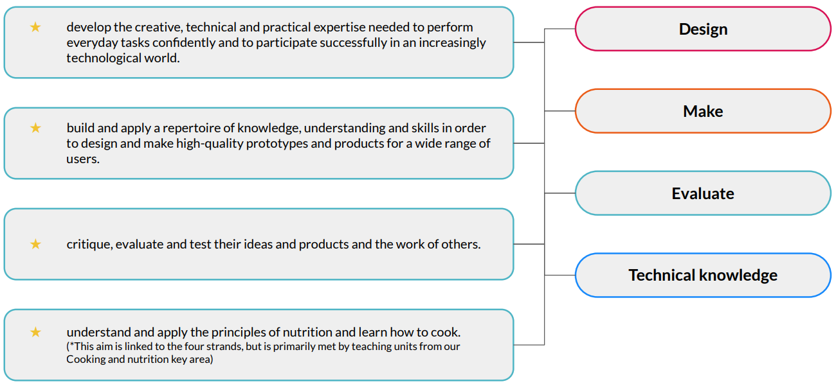

Our curriculum overview document shows which of our units cover each of the National curriculum attainment targets and all of the strands above. Each lesson plan references the relevant National curriculum objectives, along with cross-curricular links to any other subjects. For EYFS (Reception) links are made to Development matters and the Early Learning Goals.

This Pathway assures full National Curriculum (England) coverage and is designed to meet the requirements of the 2019 Ofsted framework. The Pathway involves six design technology schemes each year, medium-term plans and schemes of work. Core skills, knowledge, vocabulary and concepts acquired in each year group are revisited. The Pathway assumes a school curriculum organised around year groups on an annual planning cycle, rather than combined year groups on a rolling cycle. It assumes that the school is able to commit approximately six lessons each term to a topic. D.T is taught in a spiral curriculum.

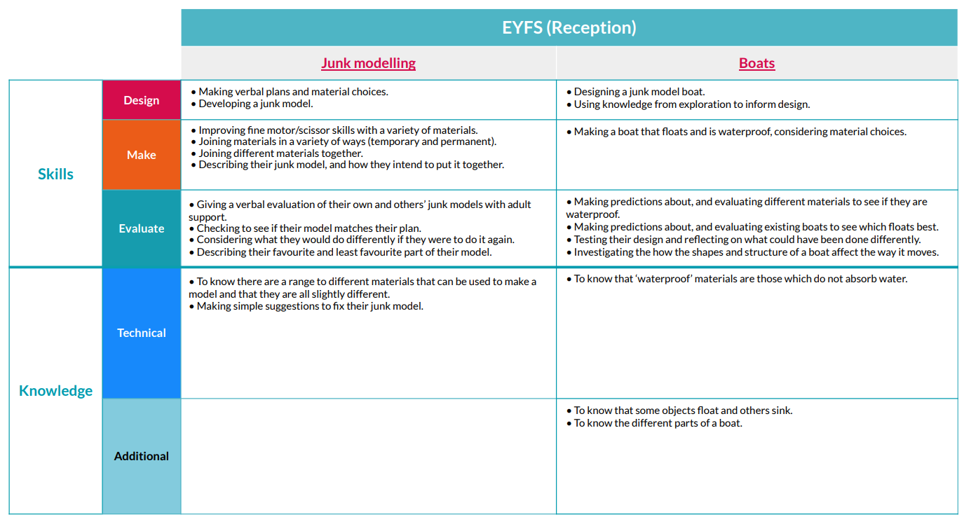

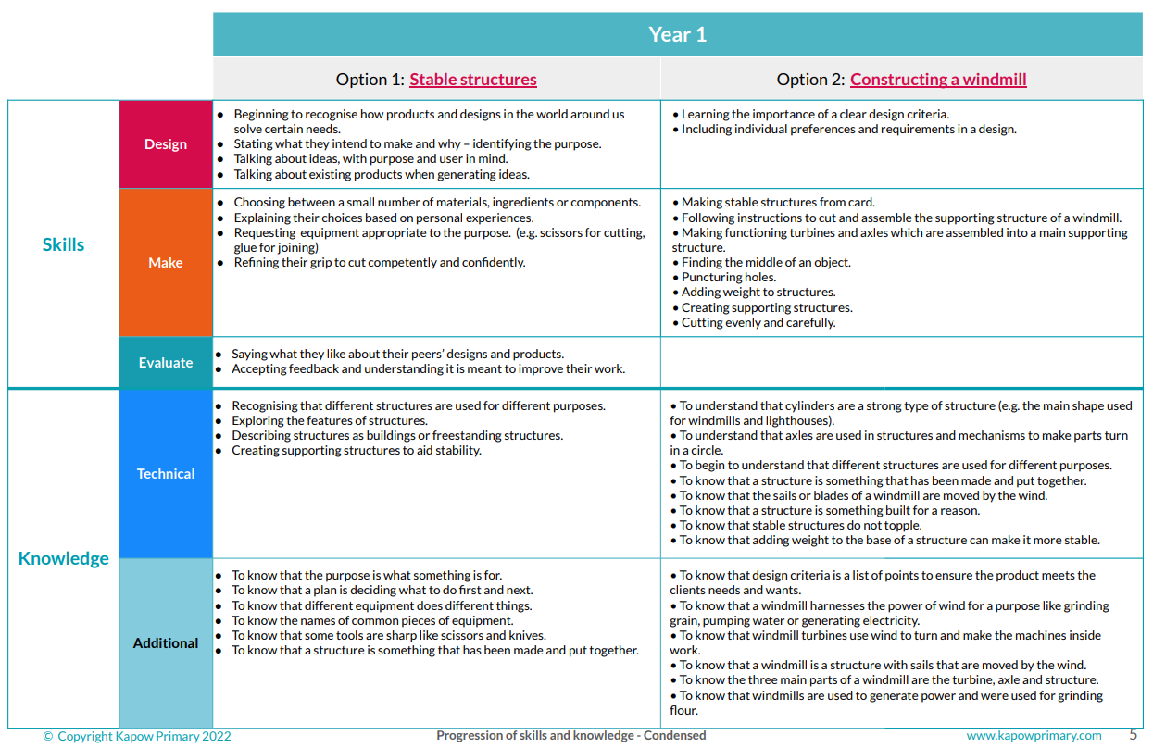

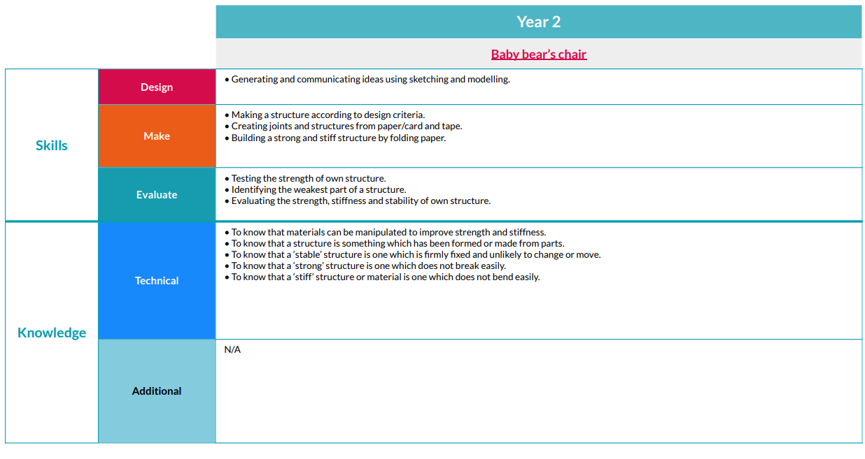

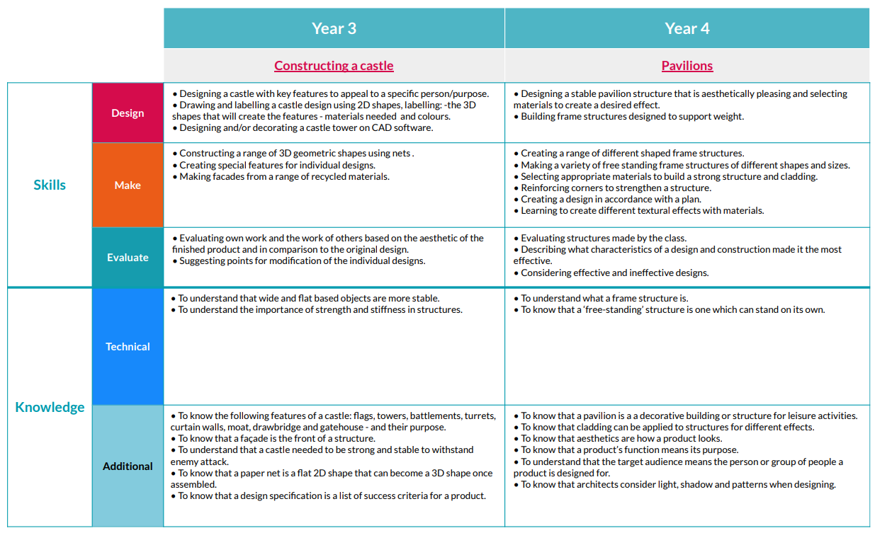

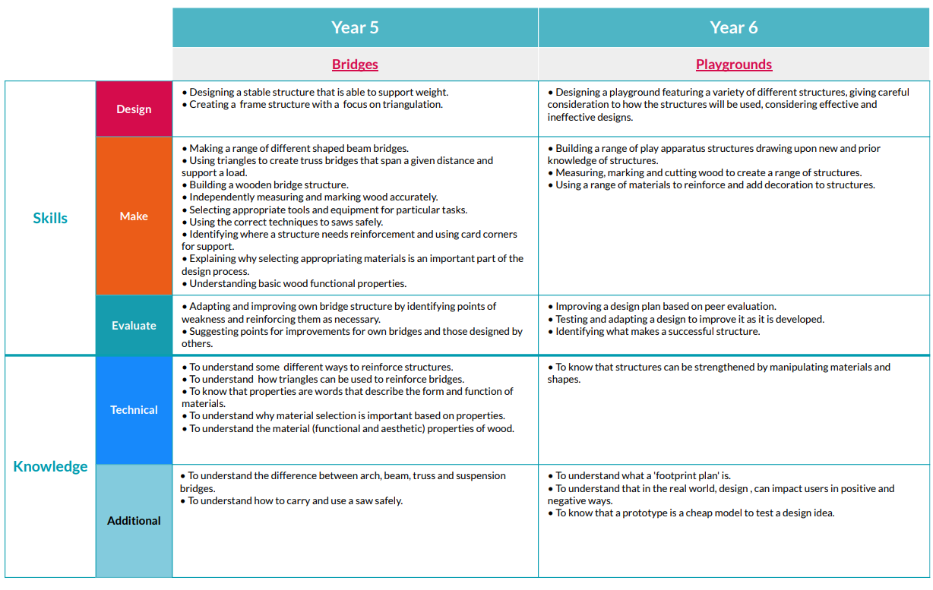

|  |  |  |  |  |  |
| --- | --- | --- | --- | --- | --- |
| **Year 1** | **Year 2** | **Year 3** | **Year 4** | **Year 5** | **Year 6** |
| By the end of year 1 children should:  **Design**  ● Think about what others might want from a design.  ● Begin to recognise how products and designs in the world around us solve certain needs.  ● Consider who they are designing for – identifying the user.  ● State what they intend to make and why – identifying the purpose.  ● Talk about ideas, with purpose and user in mind.  ● Talk about existing products when generating ideas.  ● Think about what others might want from a design.  • Design smoothie carton packaging by-hand.  • Learn where and how fruits and vegetables grow.  • Use a template to create a design for a puppet. | By the end of year 2 children should know:  **Design**  • Generate and communicate ideas using sketching and modelling.  • Learn about different types of structures, found in the natural world and in everyday objects.  ● Conduct simple surveys or discussions to gather opinions on what others need or like in a design.  ● Know that a survey is used to find out what people like.  ● Use a simple design brief that outlines the intended use, target user, and key features of the product, to create simple design criteria.  ● Know that a design brief helps to decide what to make.  ● Know that design criteria are the steps for making a product successful.  ● Create ideas with design criteria in mind.  ● Refer to specific parts of existing products when generating ideas.  ● Know that the design criteria help when thinking of ideas.  ● Use labels to explain parts of a design, label materials, etc.  ● Know that drawings can help explain how something works.  ● Know that a label explains part of a drawing.  • Design three wrap ideas  Design a pouch. | By the end of year 3 children should know:  **Design**  • Design a castle with key features to appeal to a specific person/purpose.  • Draw and label a castle design using 2D shapes, labelling: -the 3D shapes that will create the features - materials needed and colours.  • Design and/or decorate a castle tower on CAD software.  ● Create simple design criteria that outline basic functionality and appeal to individual users or target audiences.  ● Take part in structured idea blasting sessions.  ● Come up with more ideas and considering the feasibility of their ideas in the classroom.  ● Develop drawing and sketching skills with a focus on clarity and simplicity.  ● Develop designs by adding detail and justifications about materials, tools, methods.  ● Begin to recognise the benefit of a range of diagram types or prototypes to communicate ideas. (eg. sketches, cross-sectional diagram, thumbnail sketches and exploded diagrams).  • Describe how climate affects where foods grow.  • Design and make a template from an existing cushion and applying individual design criteria.  • Problem solve by suggesting which features on a micro:bit might be useful and justify my ideas.  • Draw and manipulate 2D shapes, using computer-aided design, to produce a point of sale badge.  • Develop design ideas through annotated sketches to create a product concept.  • Develop design criteria to respond to a design brief | By the end of year 4 children should know:  **Design**  • Design a stable pavilion structure that is aesthetically pleasing and selecting materials to create a desired effect.  • Design a shape that reduces air resistance.  • Draw a net to create a structure from.  • Choose shapes that increase or decrease speed as a result of air resistance.  • Personalise a design.  • Design a torch, giving consideration to the target audience and create both design and success criteria focusing on features of individual design ideas.  • Design a biscuit within a given budget.  • Conduct market research.  • Write design criteria for a product, articulating decisions made.  • Design a personalised book sleeve. | By the end of year 5 children should know:  **Design**  • Design a stable structure that is able to support weight.  • Create a frame structure with a focus on triangulation.  • Identify factors that could be changed on existing products and explaining how these would alter the form and function of the product.  • Develop design criteria based on findings from investigating existing products.  • Develop design criteria that clarifies the target user  • Research existing recipes.  • Suggest alternative ingredients.  • Design a jar label.  • Research (books, internet) for a particular (user’s) animal’s needs.  • Develop design criteria based on research.  • Generate multiple housing ideas using building bricks.  • Understand what a virtual model is and the pros and cons of traditional and CAD modelling.  • Place and manoeuvring 3D objects, using CAD.  • Change the properties of, or combine one or more 3D objects, using CAD. | By the end of year 6 children should know:  **Design**  • Design a playground featuring a variety of different structures, giving careful consideration to how the structures will be used, considering effective and ineffective designs  ● Notice wider-reaching problems or needs in the community.  ● Come up with a broader range of ideas and deeper innovation, requiring pupils to think critically about their ideas’ practicality and originality.  ● Begin to use more complex annotated sketches, such as cross-sectional and exploded diagrams and pattern pieces in design.  • Design a steady hand game - identifying and naming the components required.  • Draw a design from three different perspectives.  • Generate ideas through sketching and discussion.  • Model ideas through prototypes.  • Write a recipe, explaining the key steps, method and ingredients.  • Include facts and drawings from research undertaken.  • Write a design brief from information submitted by a client.  • Develop design criteria to fulfil the client’s request.  • Consider and suggesting additional functions for my navigation tool.  • Develop a product idea through annotated sketches.  • Place and manoeuvre 3D objects, using CAD.  • Change the properties of, or combining one or more 3D objects, using CAD. |
| **Make**  ● Choose between a small number of materials, ingredients or components.  ● Explain their choices based on personal experiences.  ● Request equipment appropriate to the purpose. (e.g. scissors for cutting, glue for joining)  ● Begin to use objects with a fixed width or length to create even spacing of markings or cuts (e.g. a lolly stick).  ● Refine their grip to cut competently and confidently.  ● Cut straight lines and evenly spaced lines.  ● Begin to cut large shapes and thicker materials like card.  ● Plan more than one step ahead.  ● Explain in simple terms why certain tools must be handled carefully.  ● Follow and recall simple safety instructions.  • Chop fruit and vegetables safely to make a smoothie.  • Juice fruits safely to make a smoothie.  • Identify if a food is a fruit.  • Cut fabric neatly with scissors.  • Use joining methods to decorate a puppet.  • Sequence steps for construction. | **Make**  • Make a structure according to design criteria.  • Create joints and structures from paper/card and tape.  • Build a strong and stiff structure by folding paper  ● Choose materials, ingredients or components from a wider range of materials, ingredients or components.  ● Explain choices based on the properties of materials and components.  ● Know some properties of materials like hard, soft, flexible, waterproof, strong etc.  ● Follow and recall simple safety instructions.  ● Know that some tools are sharp like scissors and knives.  ● Choose known geometric shapes when making.  ● Begin to shape objects to improve how they work.  ● Know the names of some geometric shapes: triangle, pyramid, square, cube, circle, sphere.  ● Consider balance in their finishing, like evenly spaced decoration.  • Chop foods safely to make a wrap.  • Construct a wrap that meets a design brief.  • Grate foods to make a wrap.  • Snip smaller foods instead of cutting.  • Spread soft foods to make a wrap.  • Identify the five food groups.  • Learn about balanced diet.  • Select and cut fabrics for sewing.  • Decorate a pouch using fabric glue or running stitch.  • Thread a needle.  • Sew running stitch, with evenly spaced, neat, even stitches to join fabric.  • Neatly pin and cut fabric using a template. | **Make**  • Construct a range of 3D geometric shapes using nets.  • Create special features for individual designs.  • Make facades from a range of recycled materials.  ● Select equipment required for a series of tasks based on the plan. Explain why each piece is suitable for each stage.  ● Suggest simple safety rules based on their understanding of tool dangers.  ● Participate in discussions about classroom safety procedures.  ● Cut out more complex shapes accurately.  ● Handle different sizes and types of scissors with confidence.  ● Use PVA glue to join corrugated card and light wood (e.g. balsa wood).  ● Choose shapes to suit the function of a product.  ● Paint or colour precisely to improve the finish.  ● Make facades from a range of materials.  ● Seal edges with tape to cover gaps in joins.  • Follow a baking recipe.  • Understand safety and hygiene rules.  • Taste seasonal ingredients.  • Peel foods by hand or with a peeler.  • Cut ingredients safely.  • Choose ingredients based on a design brief  • Follow design criteria to create a cushion or Egyptian collar.  • Select and cut fabrics with ease using fabric scissors.  • Thread needles with greater independence.  • Tie knots with greater independence.  • Sew cross stitch to join fabric.  • Decorate fabric using appliqué.  • Complete design ideas with stuffing and sew the edges (Cushions) or embellish the collars based on design ideas (Egyptian collars)  • Follow a list of design requirements.  • Write a program to control (button press) and/or monitor (sense light) that will initiate a flashing LED algorithm. | **Make**  • Build frame structures designed to support weight.  • Create a range of different shaped frame structures.  • Make a variety of free-standing frame structures of different shapes and sizes.  • Select appropriate materials to build a strong structure and cladding.  • Reinforce corners to strengthen a structure.  • Create a design in accordance with a plan.  • Make a torch with a working electrical circuit and switch.  • Use appropriate equipment to cut and attach materials.  • Assemble a torch according to the design and success criteria.  • Learn to create different textural effects with materials.  • Measure, mark, cut and assemble with increasing accuracy.  • Make a model based on a chosen design.  • Adapt a recipe.  •Identify seasonal ingredients from the UK.  •Follow the instructions within a recipe.  • Make and test a paper template with accuracy and in keeping with the design criteria.  • Measure, mark and cut fabric using a paper template.  • Select a stitch style to join fabric, working neatly by sewing small, straight stitches.  • Incorporate fastening to a design.  • Alter a product’s form and function by tinkering with its configuration.  • Make a functional series circuit, incorporating a motor.  • Construct a product with consideration for the design criteria. | **Make**  • Make a range of different shaped beam bridges.  • Use triangles to create truss bridges that span a given distance and support a load.  • Build a wooden bridge structure.  • Independently measure and mark wood accurately.  • Select appropriate tools and equipment for particular tasks.  • Use the correct techniques to saw safely.  • Identify where a structure needs reinforcement and use card corners for support.  • Explain why selecting appropriating materials is an important part of the design process.  • Understand basic wood functional properties.  ● Consistently apply safety instructions.  ● Select appropriate scissors to handle delicate cutting tasks and challenging materials.  ● Cut patterns and drawings accurately.  ● In supervised groups, use hot glue guns safely.  ● Recognise that hot glue is useful for joining materials that need a strong bond that sets quickly.  ● Choose PVA glue over hot glue for its safety when joining materials in less intensive projects.  • Write an alternative recipe.  • Understand cross-contamination.  • Use preparation skills.  • Make a developed recipe  • Understand the functional and aesthetic properties of plastics.  • Use programming to monitor the ambient temperature and coding an (audible or visual) alert when the temperature rises above or falls below a specified range. | **Make**  • Build a range of play apparatus structures drawing upon new and prior knowledge of structures.  • Measure, mark and cut wood to create a range of structures.  • Use a range of materials to reinforce and add decoration to structures.  ● Produce lists of equipment, materials and tools that they need for a task.  ● Select materials, components or ingredients based on research or user needs.  ● Explain their choices, referring to their research.  ● Consider which equipment will work well together.  ● Choose from the known range of equipment available to them with little guidance.  ● Assess risks associated with different tools and equipment.  ● Understand and explaining the importance of each safety rule.  ● Consistently apply safety instructions.  ● Cut jelutong or other harder wood with a coping saw or a tenon saw in small groups.  ● Cut in a back-and-forth sawing motion where appropriate.  ● In supervised groups, use hot glue guns safely.  ● Recognise that hot glue is useful for joining materials that need a strong bond that sets quickly  • Construct a stable base for a game.  • Accurately cut, fold and assemble a net.  • Decorate the base of the game to a high-quality finish.  • Make and test a circuit.  • Incorporate a circuit into a base.  • Follow a recipe, including using the correct quantities of each ingredient.  • Adapt a recipe based on research.  • Work to a given timescale.  • Work safely and hygienically with independence.  • Consider materials and their functional properties, especially those that are sustainable and recyclable (for example, cork and bamboo).  • Explain material choices and why they were chosen as part of a product concept.  • Programming an N, E, S, W cardinal compass. |
| **Evaluate**  ● Discuss existing products, saying what they like about them.  ● Compare two products and discuss which is better for a specific purpose.  ● Say what they like about their peers’ designs and products.  ● Accept feedback and understanding it is meant to improve their work  ● Discuss how their products could be improved based on personal preferences.  • Taste and evaluate different food combinations.  • Describe appearance, smell and taste.  • Suggest information to be included on packaging.  • Compare their own smoothie with someone else’s.  • Reflect on a finished product, explaining likes and dislikes. | **Evaluate**  • Test the strength of own structure.  • Identify the weakest part of a structure.  • Evaluate the strength, stiffness and stability of own structure  ● Discuss a range of existing products and saying what they like and dislike about them.  ● Evaluate existing products against design criteria.  ● Evaluate ideas and creations against simple design criteria.  ● Know that design criteria help to decide if their product is a success.  ● Suggest improvements to peers’ designs and products.  ● Know that improve means to make something better.  ● Know that their suggestions can improve someone else’s work.  • Describe appearance, smell and taste.  • Taste and evaluate different food combinations.  • Describe the information that should be included on a label  • Troubleshoot scenarios posed by teacher.  • Evaluate the quality of the stitching on others’ work.  • Discuss as a class, the success of their stitching against the success criteria.  • Identify aspects of their peers’ work that they particularly like and why. | **Evaluate**  • Evaluate own work and the work of others based on the aesthetic of the finished product and in comparison, to the original design.  • Suggest points for modification of the individual designs.  ● Analyse why specific products, designers or inventors are successful.  ● Evaluate designs by comparing them against design criteria and consider feedback from peers to suggest improvements.  ● Explain why they think certain aspects of a peer's design are effective. Explain suggested specific improvements.  ● Reflect on feedback to decide if and how it could be used to improve future work  • Evaluate an adapted recipe.  • Evaluate and compare a range of products.  • Suggest modifications.  • Describe the texture and flavour of ingredients.  • Describe the benefits of seasonal fruits and vegetables and the impact on the environment.  • Suggest modifications. | **Evaluate**  • Evaluate structures made by the class.  • Describe which characteristics of design and construction make it the most effective.  • Consider effective and ineffective designs.  • Evaluate the speed of a final product based on: the effect of shape on speed and the accuracy of workmanship on performance.  • Evaluate electrical products.  • Test and evaluate the success of a final product  • Evaluate an adapted recipe.  • Evaluate and compare a range of products.  • Test and evaluate an end product against the original design criteria.  • Decide how many of the criteria should be met for the product to be considered successful.  • Suggest modifications for improvement.  • Articulate the advantages and disadvantages of different fastening types. | **Evaluate**  • Adapt and improve own bridge structure by identifying points of weakness and reinforcing them as necessary.  • Suggest points for improvements for own bridges and those designed by others  ● Reflect on the usability, aesthetics, innovation and sustainability of products and discussing how design choices impact these aspects.  ● Assess their designs against a more complex set of design criteria that includes functionality, aesthetics, user experience, sustainability and cost.  ● Consider alternative materials, tools or techniques that could enhance the product.  ● Provide feedback that is helpful, specific, and encouraging.  ● Incorporate feedback from peers or users improve their product further, explaining the changes they made and the impact they had.  • Carry out a product analysis to look at the purpose of a product along with its strengths and weaknesses.  • Determine which parts of a product affect its function and which parts affect its form.  • Analyse whether changes in configuration positively or negatively affect an existing product.  • Explain the farm to fork process.  • Analyse nutritional content.  • State an event or fact from the last 100 years of plastic history.  • Explain how plastic is affecting planet Earth and suggesting ways to make more sustainable choices.  • Explain key functions in my program (audible alert, visuals).  • Explain how my product would be useful for an animal carer including programmed features | **Evaluate**  • Improve a design plan based on peer evaluation.  • Test and adapt a design to improve it as it is developed.  • Identify what makes a successful structure.  ● Assess their designs against a more complex set of design criteria that includes functionality, aesthetics, user experience, sustainability and cost.  ● Provide feedback that is helpful, specific and encouraging.  ● Incorporate feedback from peers or users to improve the product further, explaining the changes made and the impact they had.  • Test own and others finished games, identifying what went well and making suggestions for improvement.  • Evaluate a recipe, considering: taste, smell, texture and origin of the food group.  • Taste test and scoring final products.  • Suggest and write up points of improvements when scoring others’ dishes, and when evaluating their own throughout the planning, preparation and cooking process.  • Evaluate health and safety in production to minimise cross contamination.  • Explain how my program fits the design criteria and how it would be useful as part of a navigation tool.  • Developing an awareness of sustainable design.  • Identify key industries that utilise 3D CAD modelling and explaining why.  • Describe how the product concept fits the client’s request and how it will benefit the customers.  • Explain the key functions in my program, including any additions.  • Explain how my program fits the design criteria and how it would be useful as part of a navigation tool.  • Explain the key functions and features of my navigation tool to the client as part of a product concept pitch.  • Demonstrate a functional program as part of a product concept pitch. |