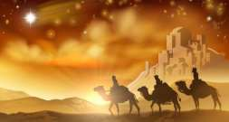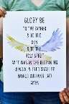

**Key Vocabulary**

Magi

welcome

Glory Be

celebrate

actions

care

|  |  |
| --- | --- |
| **Celebrate:**  **How do we act as Christians?** | |
| That the Church prays the ‘Glory Be’ as a response to the coming of  Jesus. |  |

|  |  |
| --- | --- |
| **Hear:**  **What Scripture will we Hear?** | |
| The visit of the Magi (Matt 2:1-12). |  |
| Jesus blesses the little children (Mk 10:13-16). |  |
| Feeding of 5000 (Jn 6:1-14). |  |

|  |  |
| --- | --- |
| **Live:**  **How do Catholics live out their Faith?** | |
| We welcome and show love to everyone in our words and  actions as Jesus does. |  |
| We are called to help the poor and hungry. |  |
| You need food, water, a house, your school, a good doctor, and a job for the grown-up who takes care of you. So does everybody else on the whole Earth. But many people do not have these things. Jesus wants us to take  extra care of these people |  |

|  |  |
| --- | --- |
| **Believe:**  **What do Christians Believe?** | |
| The Magi visited Jesus with gifts. Jesus is God’s Son and came for everyone. |  |
| Jesus’ birth is celebrated at Christmas. |  |
| Jesus came to show God’s love and welcomes everyone. |  |
| Jesus takes care of everyone. |  |

Remember in Nursery, we learned:

The Wise Men visited Jesus.

Reception

**Galilee to Jerusalem**

Later, in Year 1 you will learn:

Jesus encountered lots of people in His life and changed their lives for the better.