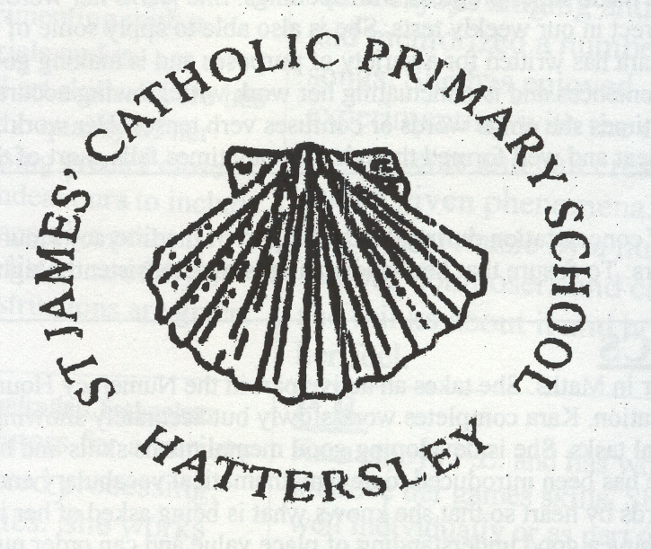
MR. M. WOOLLEY CHERITON CLOSE
HEADTEACHER HATTERSLEY
HYDE
TEL: 0161 368 3455 CHESHIRE
FAX: 0161 368 3177 SK14 3DQ
admin@st-james-hyde.tameside.sch.uk

1st October 2024

Dear Parents / Carers

At St James’ we value the positive relationships formed with our parents, carers & visitors to school. We wish to work in partnership with parents and carers in order to create the best learning opportunities for their child.

Almost all parents, carers and visitors to St James’ are keen to work with us and are supportive of the school and our procedures. However, on rare occasions, the behaviour of some of our parents falls short of what we expect. This sometimes manifests itself in aggression, swearing, offensive language or abuse towards members of staff or other parents.

We expect all members of staff to behave professionally, attempting to defuse the situation where possible and seeking the involvement of other colleagues as appropriate. However, staff also have a right to end any conversation (face to face or on the telephone) should they feel they are being threatened or are dealing with aggressive or abusive parents or carers.

All members of staff have the right to work without fear of threat, violence or abuse.

We expect all parents or carers to:

- Treat all members of the school community with respect – setting a good example with speech and behaviour.
- Seek a peaceful solution to all issues, rather than shouting or displaying a temper to staff, pupils or other parents.
- Not discipline another person’s child – please bring any behaviour incidents to a member of staff’s attention.
- Approach the right member of school staff to help resolve any issues of concern.
- Not swear or use offensive language.
- Not use threatening behaviour towards any member of the school community.
- Not send abusive messages to another member of the school community, including via text, email or social media.
- Not post defamatory, offensive or derogatory comments about the school, its staff or any member of its community on social media platforms.

I am currently working on a new parent code of conduct for our governors to approve at their next meeting. This will then be made available for parents to sign.
Thank you for your co-operation in this matter.
Yours Faithfully
Mr M Woolley
Headteacher

