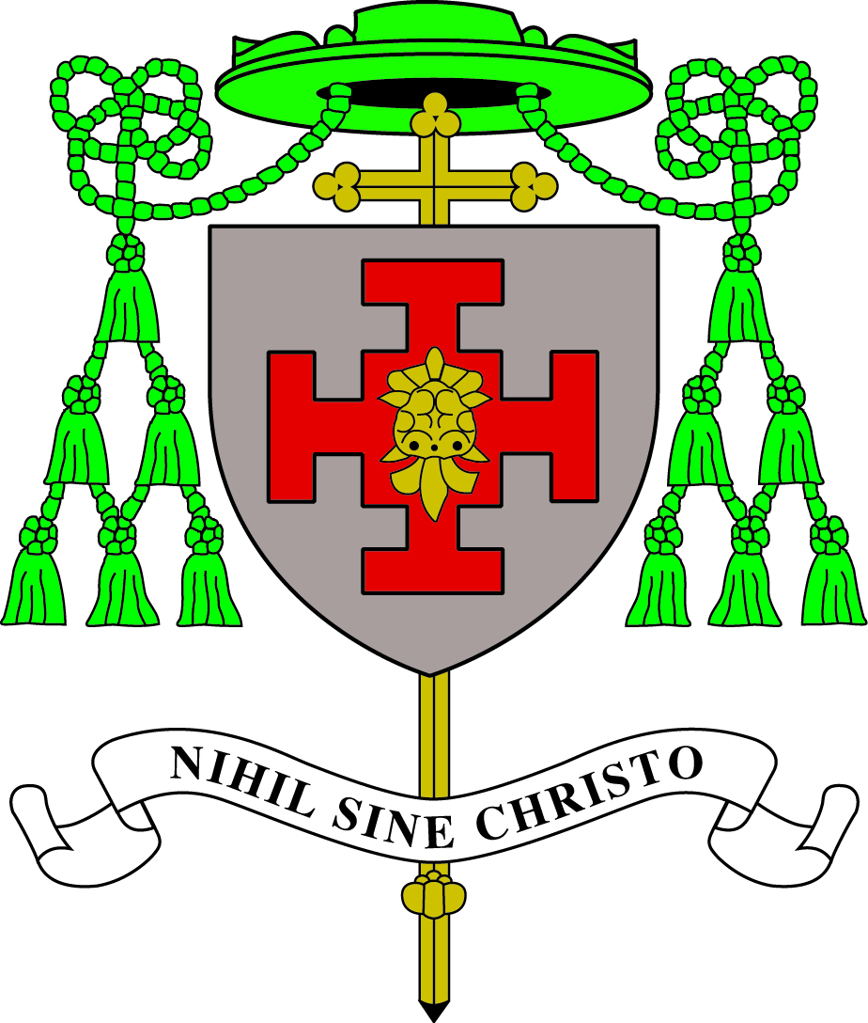
Diocese of Shrewsbury in partnership with
Tameside M.B.C.
ST JAMES’ CATHOLIC PRIMARY SCHOOL
Cheriton Close, Hattersley SK14 3DQ
Tel: 0161 368 3455
www.st-james-hyde.tameside.sch.uk
E mail:admin@st-james-hyde.tameside.sch.uk

Teaching Assistant

Level 3

Required for September 2024

(or sooner if possible)

Do you really want to make a difference?
Are you ready to work in a school where the children really need you and are willing to give you their very best in everything?

If so, the Governors of St James’ Catholic Primary School are seeking to appoint a level 3 Teaching Assistant to work across the school but predominantly in KS2.

We are seeking a colleague who is:
- A practising Catholic or sympathetic to the teachings of the Catholic Church
- A qualified level 3 Teaching Assistant with experience of KS2
- Is approachable, friendly, enthusiastic, hardworking and a good communicator with a sense of humour
- Committed to promoting high standards of attainment and behaviour
- Willing to contribute to the full life of the school and the parish
- Able to work well in a team and contribute to the further development of our school
- Has the ability to take the initiative to deal with problems as they arise

We can offer:
- A warm community with a strong Catholic Ethos
- A happy and supportive working environment
- Lively but well behaved children who enjoy learning
- A friendly and dedicated staff team.
- Good relationships with parents and the parish family
- A supportive governing body

Our school is committed to safeguarding and promoting the welfare of children and expects all staff to share this commitment. We will require a CES contract to be signed and evidence of identity and qualifications to be provided. This post is subject to a satisfactory enhanced DBS disclosure.

**Please note applications must be on the CES application form. Tameside application forms will not be accepted.

Application forms and job information can be found at Greater Jobs https://www.greater.jobs/

Application forms to be returned to Mr Mark Woolley, headteacher elect on admin@st-james-hyde.tameside.sch.uk

Informal enquiries and visits to school are most welcome.

CLOSING DATE Wednesday 15t^{h} May (12 noon)
SHORTLISTING Wednesday 15 ^{th} May
OBSERVATIONS Thursday 23rd May (at St James’)
INTERVIEWS Thursday 23rd May

