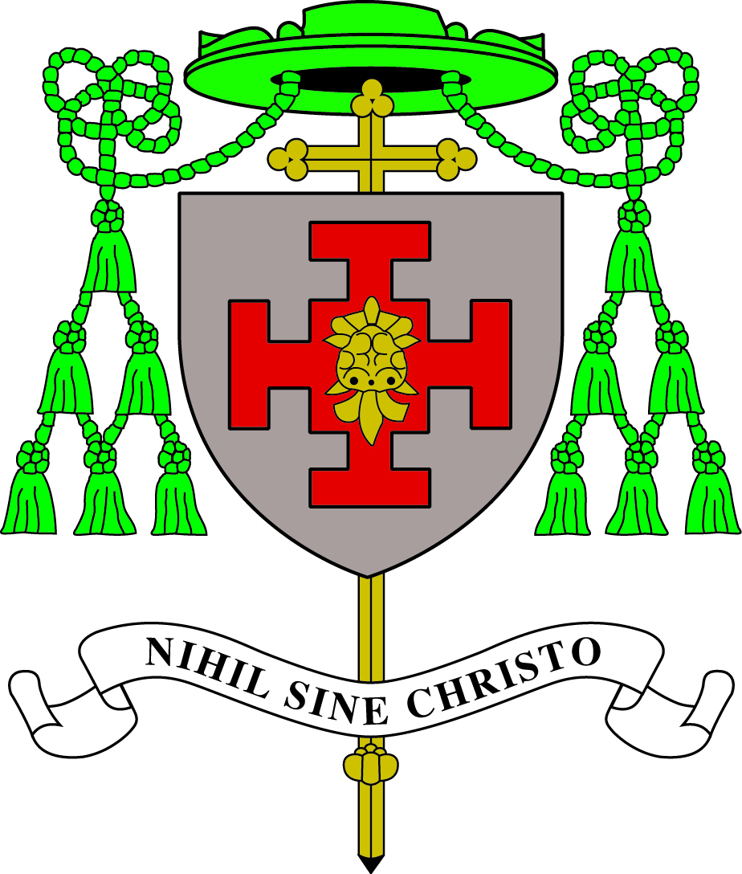
Diocese of Shrewsbury in partnership with
Tameside M.B.C.
ST JAMES’ CATHOLIC PRIMARY SCHOOL
Cheriton Close, Hattersley SK14 3DQ
Tel: 0161 368 3455
Fax: 0161 368 3177
E mail:admin@st-james-hyde.tameside.sch.uk

KEY STAGE 2 CLASS TEACHER
(preferably upper KS2)
Required for September 2024

Do you really want to make a difference?
Are you ready to work in a school where the children really need you and are willing to give you their very best in everything?
If so, the governors of St James’ Catholic Primary School, Hattersley, would love to hear from you.

We offer:
- A strong Catholic ethos
- A happy and supportive working environment
- An experienced and dedicated staff
- Good relationships with parents and the parish family
- Friendly children who are eager to learn
- A supportive governing body

We are seeking a colleague who is:
- A practising Catholic or sympathetic to the teachings of the Catholic Church
- A qualified teacher with experience of KS2, preferably in upper KS2
- Enthusiastic, motivated, hardworking and inspirational
- Committed to promoting high standards of attainment and behaviour
- Willing to contribute to the full life of the school and the parish
- Able to work well in a team and contribute to the further development of our school

Visits to school are warmly welcomed and positively encouraged. Please contact Mr Mark Woolley, Headteacher elect, for an appointment.

Our school is committed to safeguarding and promoting the welfare of children and expects all staff to share this commitment. We will require a CES contract to be signed and evidence of identity and qualifications to be provided. This post is subject to a satisfactory enhanced DBS disclosure.

**Please note applications must be on the CES application form. Tameside application forms will not be accepted.

Application forms and job information can be found at Greater Jobs https://www.greater.jobs/Application. Application Forms to be returned to Mr Mark Woolley, headteacher elect on admin@st-james-hyde.tameside.sch.uk

CLOSING DATE Friday 10th May (12 noon)
SHORTLISTING Friday 10th May
OBSERVATIONS 20th- 22nd May
INTERVIEWS Thursday 23rd May

