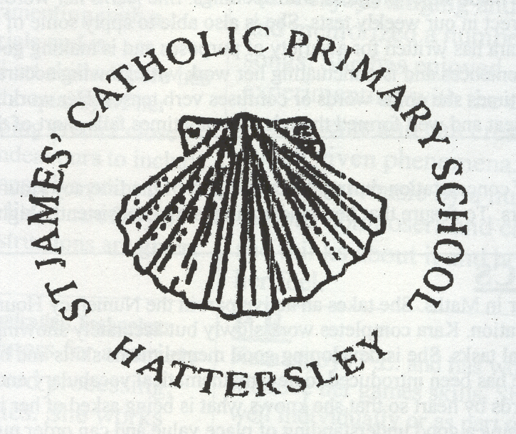

ST JAMES CATHOLIC PRIMARY SCHOOL
HOLIDAY LIST 2022 - 2023

AUTUMN 2022

SCHOOL OPENS | SCHOOL CLOSES
Monday 5th September 2022 | Thursday 20th October 2022

HALF TERM

Monday 31st October 2022 | Wednesday 21st December 2022

SPRING 2023

SCHOOL OPENS | SCHOOL CLOSES
Wednesday 4th January 2023 | Friday 17th February 2023

HALF TERM

Monday 27th February 2023 | Wednesday 5th April 2023

SUMMER 2023

SCHOOL OPENS | SCHOOL CLOSES
Wednesday 19th April 2023 | Friday 26th May 2023

HALF TERM

Monday 12th June 2023 | Friday 21st July 2023

INSET DAYS: Thursday 1st September 2022
Friday 2nd September 2022
Friday 21st October 2022
Tuesday 3rd January 2023
Monday 24th July 2023

BANK HOLIDAYS: Monday 1st May 2023

