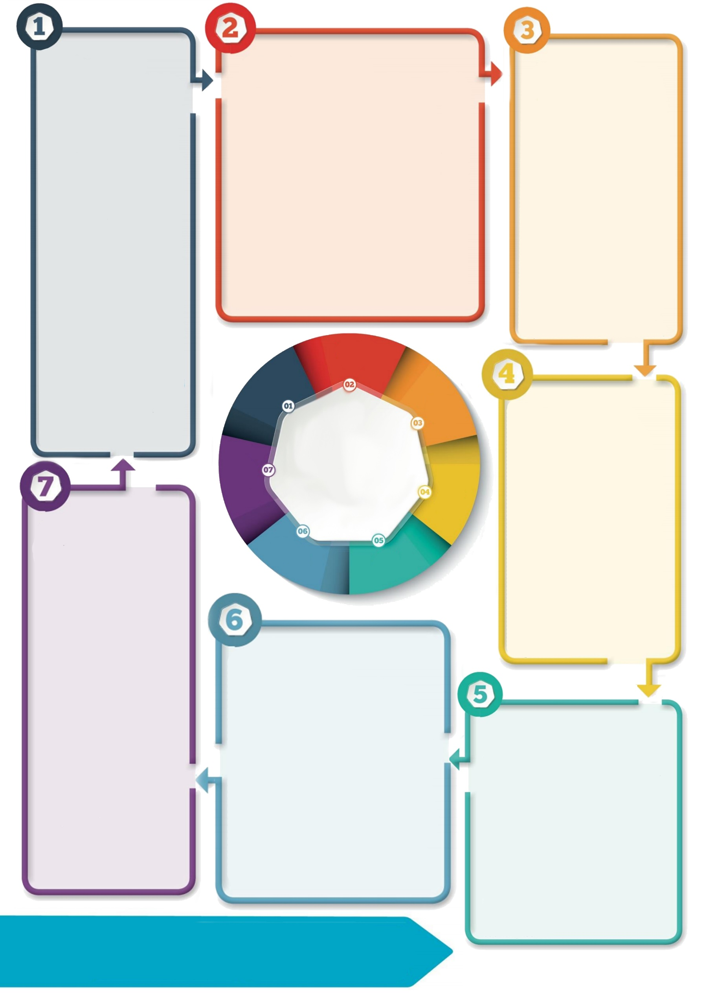

**Saying goodbye**

Create a memory book with your child to help them capture all of the things they have enjoyed about primary school.

Think about how the ending can be marked, such as ‘last day’ celebrations and swapping messages with other children and staff. Find out what the primary school are doing to say goodbye to Year 6 (e.g. leavers’ hoodies or books).

**Year 6 Parent Tips**

**Supporting the transition to secondary school**

**Further resources**

ASDAN resources for travel and using a phone - <https://www.asdan.org.uk/resources/free-resources#lift-off-transition>

BBC Bitesize resources for starting secondary school - <https://www.bbc.co.uk/bitesize/tags/zh4wy9q/starting-secondary-school/1>

ChildLine support around moving schools - <https://www.childline.org.uk/info-advice/school-college-and-work/school-college/moving-schools/>

Young Minds resources including tips for parents - <https://youngminds.org.uk/resources/school-resources/?f2=10143#listing>

**Connecting with new staff**

Look at pictures or welcome videos from the staff so some faces will be familiar in September. Key people might be the Head Teacher, Head of Year and Form Tutor.

Think about key information your child might want new staff to know about them (e.g. their strengths, what they like, how best to help them), which could be used in an All About Me booklet or One Page Profile.

**New school environment**

Visit the high school website – do they have a virtual tour to help your child get to know what their new school looks like?

Visit the school so your child can become familiar with what the outside looks like.

Find out about how the school day is structured and practise reading a timetable. Find out what clubs or activities are available.

**Independence skills**

Before and during the holidays practise skills such as:

* Telling the time.
* Travelling to and from school – including walking the journey or getting the bus
* Using money.
* Making a packed lunch.
* Packing a bag for school and organising equipment.
* Being aware of who to contact in an emergency and how to do this.

**Make time to talk**

Acknowledge that this is a big change and your child might have lots of different feelings about moving school. They might be excited but also have worries about what high school will be like. They may feel a sense of loss and worry about missing their old school, teachers and friends. All of these are natural to have!

Give your child opportunities to talk about how they feel and ask questions. Help them put together questions and think about how they can find out more about their new school.

**Contact details: If you’d like to discuss further please contact the Educational Psychology Service (EPS@salford.gov.uk or educationpsychology@tameside.gov.uk)**

**Background**

Transition to secondary school is a major milestone for children. Due to COVID-19, schools may be more restricted in what they can offer to support transitions (e.g. visits, taster days, ‘goodbye’ events at primary school), which might add to the anxiety children and parents may already be feeling.

Although there is still lots of uncertainty about how things will look in September, there are some key things that parents can do to help their children get ready.