MRS J. WALKER
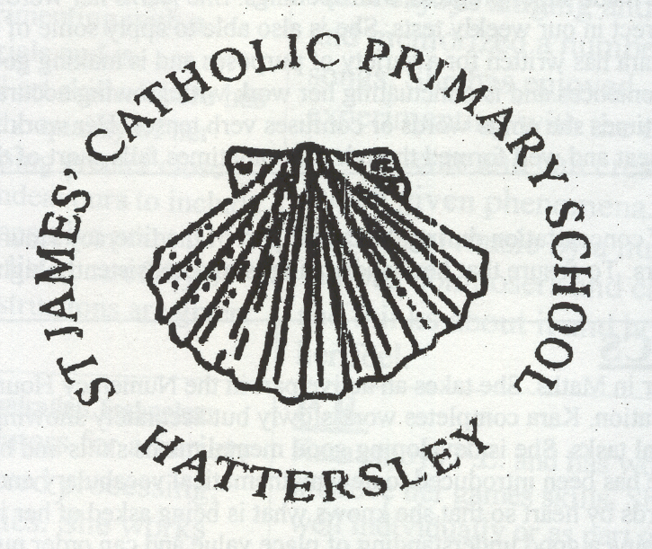
HEADTEACHER
CHERITON CLOSE
HATTERSLEY
HYDE
TEL: 0161 368 3455 CHESHIRE
FAX: 0161 368 3177 SK14 3DQ
admin@st-james-hyde.tameside.sch.uk

Date: 10/11/2021
Warn and Inform
Dear Parent/ Carer,
We have been advised by Tameside Council’s Public Health Team that there has been a confirmed case of COVID-19 within Class 2 at school.
In line with the national guidance, children aged under 18 years are no longer required to self-isolate if they are a close contact of someone who has tested positive for COVID-19.
Your child and other members of your household can continue normal activities provided your child does not develop symptoms.
People who have been in contact with someone who has tested positive with COVID-19 are advised to get a PCR test, whether or not they have symptoms. If this test is positive, they must isolate for 10 days. PCR tests can be booked via https://www.gov.uk/guidance/coronavirus-covid-19-getting-tested or by calling 119.
Children who are aged under 5 years old who are identified as close contacts will only be advised to take a PCR test if the positive case is in their own household.
Please note people should not need to be re-tested via an LFD test or PCR test within 90 days of a previous confirmed positive test, unless new symptoms develop, in which case they should book a PCR.
What to do if your child develops symptoms of COVID-19
If your child develops symptoms of COVID-19, they must isolate and you should arrange a test for your child via https://www.gov.uk/guidance/coronavirus-covid-19-getting-tested or by calling 119.
If the test result is positive, your child will be required to self-isolate for a period of 10 days from the day that their symptoms started. Please inform us if your child has a positive test result.
If your child’s test result is negative, they can continue with their normal activities if they are well enough to do so.
Please visit the link to Public Health England’s guidance for households with possible Covid-19 infections: https://www.gov.uk/government/publications/covid-19-stay-at-home-guidance/stay-at-home-guidance-for-households-with-possible-coronavirus-covid-19-infection
Symptoms of COVID-19
The most common symptoms of coronavirus (COVID-19) are recent onset of:
· new continuous cough and/or;
· high temperature and/or;
· a loss of, or change in, normal sense of taste or smell (anosmia).
However, people frequently present with a wider range of symptoms. If you or your child feel newly unwell with Covid-19 symptoms, then please access a PCR test. For many people, coronavirus (COVID-19) will be a mild illness.
How to stop COVID-19 spreading
There are things you can do to help reduce the risk of you and anyone you live with getting COVID-19:
· wash your hands with soap and water often – do this for at least 20 seconds;
· use hand sanitiser gel if soap and water are not available;
· wash your hands as soon as you get home;
· cover your mouth and nose with a tissue or your sleeve (not your hands) when you cough or sneeze;
· allow ventilation in the house through opening windows;
· put used tissues in the bin immediately and wash your hands afterwards.
Test and Trace Support Payments
If a person is asked to self-isolate by NHS Test and Trace and is on a low income, unable to work from home and will lose income as a result, they may be entitled to a payment of £500 from their local authority under the Test and Trace Support Payment scheme. This now applies to parents/ carers who cannot work from home and will lose income by self-isolating or staying at home to care for the child.
Further details are available via: https://www.gov.uk/test-and-trace-support-payment
Further Information Further information is available at https://www.nhs.uk/conditions/coronavirus-covid-19/
Yours Sincerely,

J.A.Walker
Headteacher

