[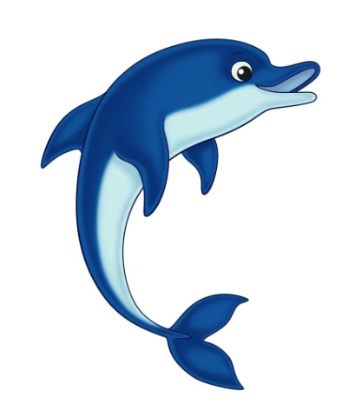](https://www.google.co.uk/url?sa=i&url=https%3A%2F%2Fwww.pinterest.com%2Fpin%2F355784439290882849%2F&psig=AOvVaw3zzZKArkLgRzsBGVjwJsLp&ust=1587816007554000&source=images&cd=vfe&ved=0CAIQjRxqFwoTCPCav_2BgekCFQAAAAAdAAAAABAJ)[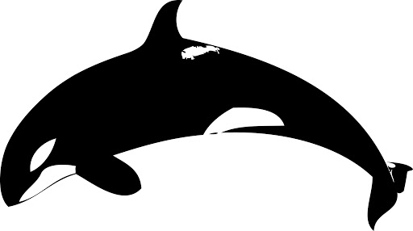](https://www.google.co.uk/url?sa=i&url=http%3A%2F%2Fclipart-library.com%2Fcartoon-killer--whale.html&psig=AOvVaw2Evcq8lp75kWfmqpSYeIQq&ust=1587816052352000&source=images&cd=vfe&ved=0CAIQjRxqFwoTCMDg65KCgekCFQAAAAAdAAAAABAD)

Choose your favourite Sea Animal and then do some research to create a Fact file all about it. If you are struggling to research it, you could write down what you know already and what information you would like to find out about it.